3v1 Rotating Defenders
This 3v1 game will focus on keeping possession in a tight space. Work on passing, decision making, movement on and off the ball as well as improve communication.

3v1 Rotating Defenders

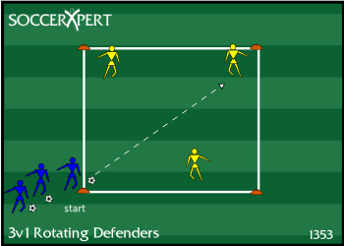

Setup
- Create a grid that is approximately 10X10 yards.
- Split players into groups of 6.
- Place 3 players inside the grid as attackers in an alternate jersey.
- The remaining 3 players line up as defenders behind one corner cone with the supply of balls.
Instructions
- The first defender passes a ball into the 3 attackers.
- The defender immediately steps into the grid and become the defender creating a 3v1 inside the grid.
- The 3 attackers attempt to put together as many passes as possible.
- The attackers continue passing until the defender wins the ball, or the ball is knocked out of play.
- Once the play is dead, the next defender plays into the same 3 attackers, and play resumes

Variations
- Adjust grid (larger grid = easier for attackers but harder for defenders; smaller grid = harder for attackers but easier for defenders)

Coaching Points
- Focus on the quality of passes such as weight, pace, accuracy.
- A well-timed run facing the passing direction will assure a more accurate pass.
- The players must communicate with each other to make the game easier.
- Players must concentrate on making runs off the ball.
- Encourage players to play in 1 or 2 touches.
- Good passes to feet
- Good first touch towards space
- Good decision making
- Speed of play/decisions

